MVTV Wireless Email Account Set Up for Android Mobile Devices

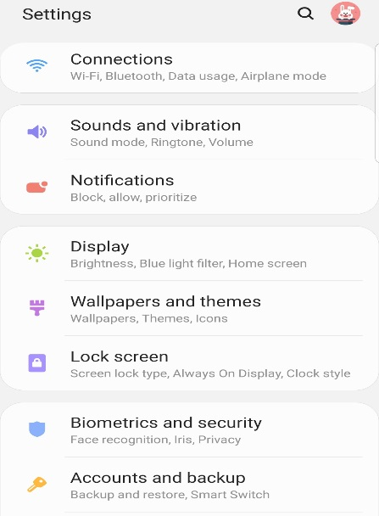
Settings
Select “Accounts and backup”

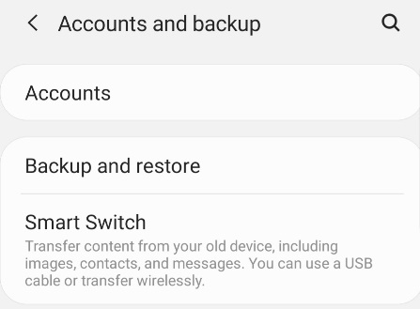

Accounts and backup
Select “Accounts”

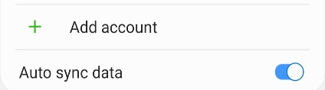
Accounts
Select “Add account”

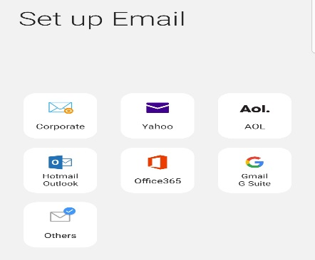

Set up Email
Select “Others”

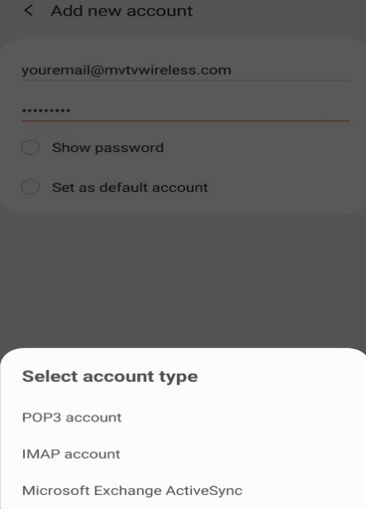

Add new account
Enter – “Your MVTV Wireless Email Address”
Enter – “Your MVTV Wireless Email Password”

Select account type
Select “POP3 account”

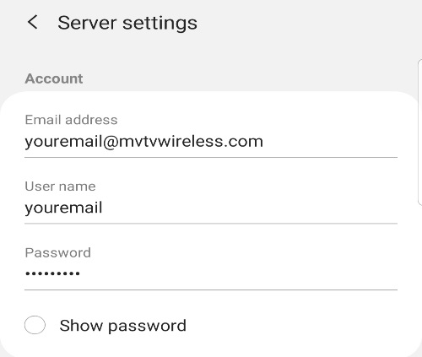
Account
Enter “Your MVTV Wireless Email Address”
Enter “User name (beginning of email address)
Enter “Your MVTV Wireless Email Password”

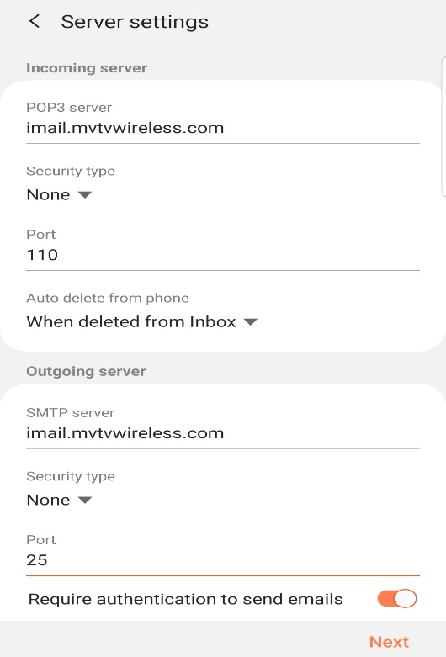

Incoming Server
POP3 Server – imail.mvtvwireless.com
Security type – None
Port 110
Auto delete from phone – choose from menu

Outgoing Server Settings
SMTP Server – imail.mvtvwireless.com
Security type – none
Port 25
Select “Next”

Manual Setup
Select your sync schedule option
Select “Done”

Edit Names
Edit account name Select “Done”

Your MVTV Wireless account in now active on your Android device!

